Brown Sugar Garlic Chicken

with Sweet & Spicy Option
Prep Time 5 min Cook Time 25 min
4 Servings

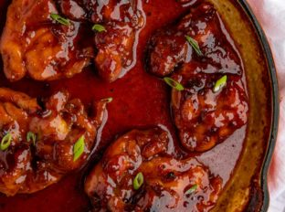
Ingredients
4 chicken thighs, boneless, skinless
2 cloves garlic - minced
½ cup light brown sugar, packed
Sweet and Spicy Option:
Just less than 1 Tablespoon Sriracha Sauce or to taste
1 teaspoon Kosher salt
¼ teaspoon coarse ground black pepper
¼ cup water

Oven
- Pre-heat oven to 425 degrees.
- Mix all the ingredients, except the chicken, together in a large bowl.
- Place the chicken into an oven safe cooking dish, pouring the sauce over the chicken in the pan.
- Bake, uncovered, for 20-25 minutes (if the sauce gets a bit dry or thick, remove chicken when done, add ½ cup water and whisk to loosen sauce, then pour over baked chicken).

Stove Top
- In a skillet over medium high heat, sear the chicken for 5-7 minutes, then flip and cook an additional 5 minutes.
- Mix all the sauce ingredients together in a large bowl and add to chicken.
- Lower the temperature to medium low and let cook until the sauce thickens and coats the chicken, about 8-10 minutes.
- Spoon the sauce over the chicken to serve.

